Joslyn Clark

Reliable Power Switching and Motor Starting Solutions for the Wind Energy Industry
Vacuum contactors are crucial in renewable energy applications such as wind. These contactors control the power flow from the wind energy source to the grid. As renewable energy sources continue to gain popularity, the need for efficient and reliable electrical equipment has become more important than ever.
Contactors are responsible for switching on and off the power supply to various parts of the turbine, including:
- Generators: Contactors act as the on/off switch for the power supply to the generator, which converts the rotational energy of the blades into electrical energy.
- Pitch Control System: Contactors help to switch on and off the power supply to the pitch control system, ensuring the blades are positioned correctly.
- Brakes: contactors switch on the power supply to the braking system, bringing the turbine to a safe stop.
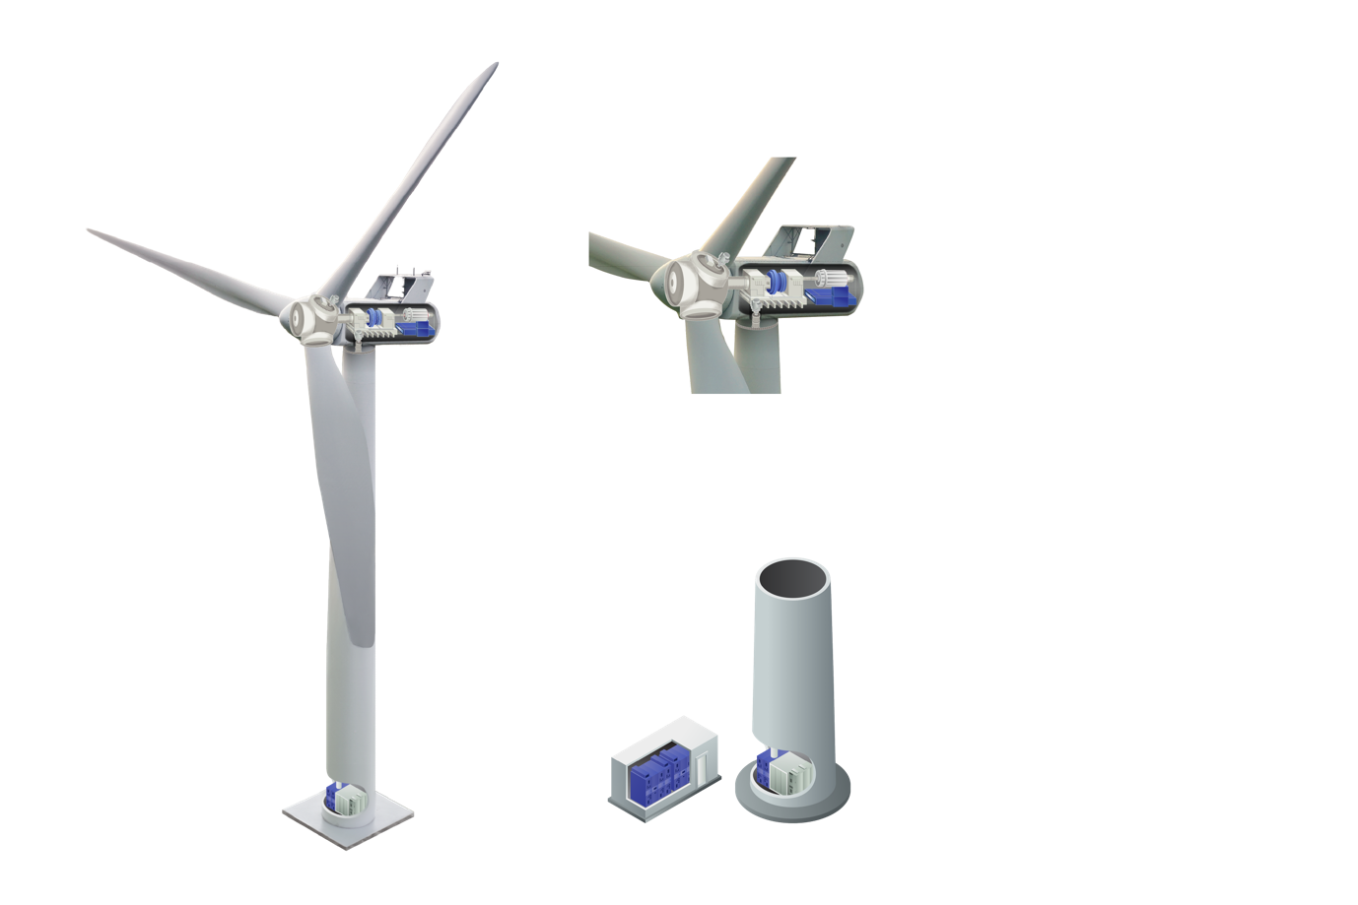

Joslyn Clark contactor experts understand the unique challenges of renewable energy applications and are committed to providing the highest quality vacuum contactors to meet those challenges. Joslyn Clark contactors can handle high voltage and current levels and switch large loads quickly and safely. Downtime can be costly, so our contactors are designed to be maintenance-free, reducing downtime and lowering operating costs.
The Advantages of Joslyn Clark contactors in Wind Energy applications include:

Durability: designed to withstand harsh weather conditions
Energy Efficient: minimizing energy loss during operation, resulting in cost savings
High Switching Capacity: to handle the high currents and voltages required in wind energy applications.
Arc Chutes: this feature ensures personnel and equipment safety by quickly extinguishing arcs
Low maintenance: minimal maintenance required, reducing downtime and increasing productivity.
If you are looking for a partner in renewable energy contactors, look no further than Joslyn Clark. Contact us today to learn more about how we can help you with your renewable energy applications.

Advantages

Long Mechanical Life
Up to 3 million operations at 30 operations per day. Life expectancy of approx. 274 years
Long Electrical Life
Up to 1 million operations at 30 operations per day. Life expectancy of approx. 91 years
Low Maintenance
No special maintenance skills or adjustments required
Minimal Downtime
Important in 24 hours operating processes
Arc Containment
No ironized gases reducing risk of flash overs
Weld Free
Minimal contact bounce, low arc energy and temperatures minimises risks of contact welding
Impervious to Environment
Contacts sealed from atmospheric contamination such as H2S Chlorine, dust, salt atmospheres, etc
High Cycle Duty up to 1200 operations/hour
Rugged, compact, quiet & lightweight
Smaller, quieter than conventional air break contactors
Simple design that mounts in any plane
Ideal for small tight packaging electrically held contactor circuit

A History of Setting the Standard by Which Others Are Measured

As the world leader in vacuum contactors and starters, we are dedicated to
continually raising the bar for industry standards of in life safety.
Dating back to the 1920’s, Joslyn Clark began as the Clark Controller Company.
Instantly recognized as a pioneer of innovation and quality, Clark products were
recognized for their advanced design and reliability. Although our name has
changed through the years, our commitment to excellence, unrivaled safety and
reliability has not.
We currently maintain a state-of-the-art manufacturing facility in Elizabethtown, NC.
Our long history of loyalty and commitment is reflected in our employees, many of
whom were on the original development team for some of our products, and are
still with us today as we continue to refine and implement new improvements and
innovations every year. This culture of low turnover and long term dedication is one
of the ways we’ve been able to build and incorporate so much innovation and long
lasting quality into our products.

For more information, visit us online at www.jdhengstler.co.uk

